**Tools Used:** SAS Enterprise Guide, Microsoft Excel

**📊 1. Objective**

To perform exploratory data analysis and regression modelling using SAS and Excel, and derive marketing insights from:

* Stock price trends (investment decision-making)
* Consumer income and product spending behavior

**🔗 2. Dataset Overview**

**Two datasets were used:**

* **Stock Data**: Share prices of IAU.TO, BTE.TO, and ACB.TO
* **Product Data**: Consumer income, education, and product category spending

**📈 3. Covariance & Correlation Analysis**

**A. Stock Data Correlation (SAS/Excel)**

* **Variables**: Daily stock prices of IAU, BTE, and ACB
* **Output Screenshot**:

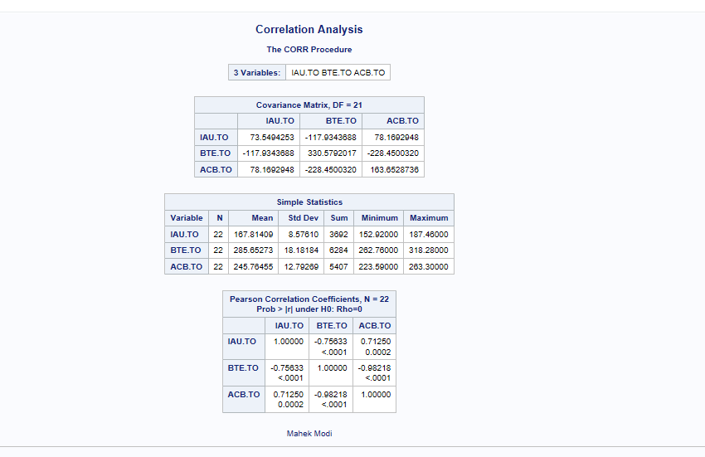

* **Interpretation**:
  + The strongest correlation was observed between **BTE** and **ACB**
  + Based on historical returns and correlation, BTE & ACB are the best investment combination in this dataset

**B. Product Data Correlation**

* **Income & Education**: Correlation = **0.917** → Strong positive

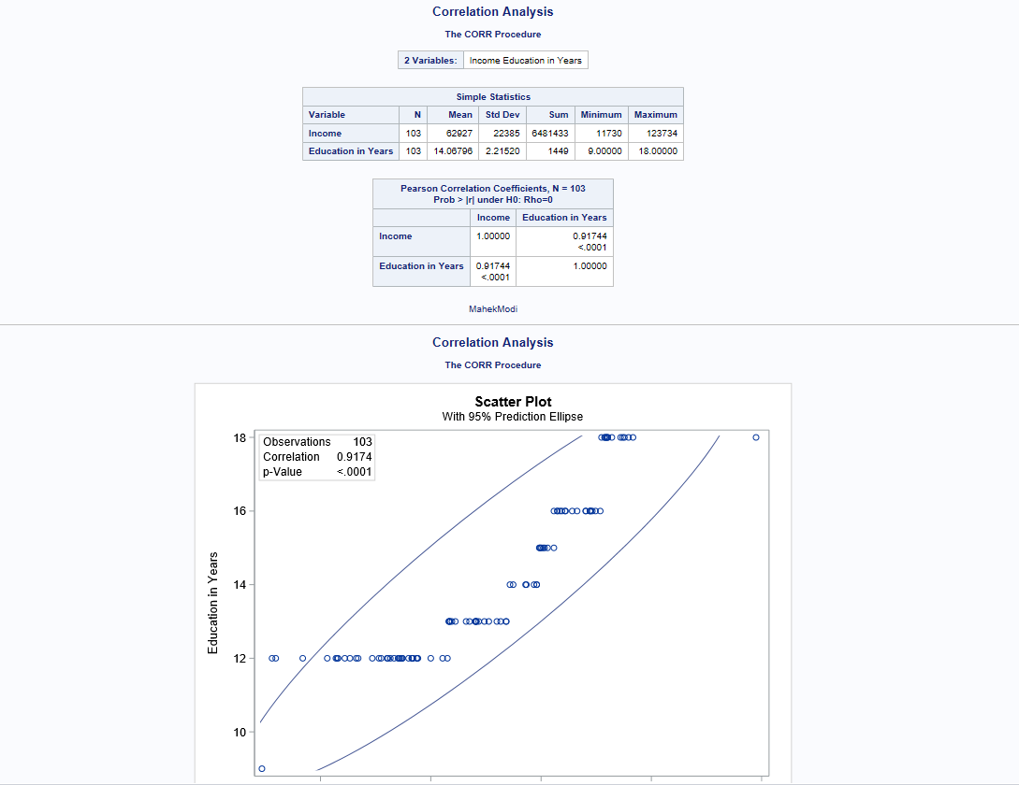

* **Fruits & Sweet Products**: Correlation = **0.453** → Moderate positive

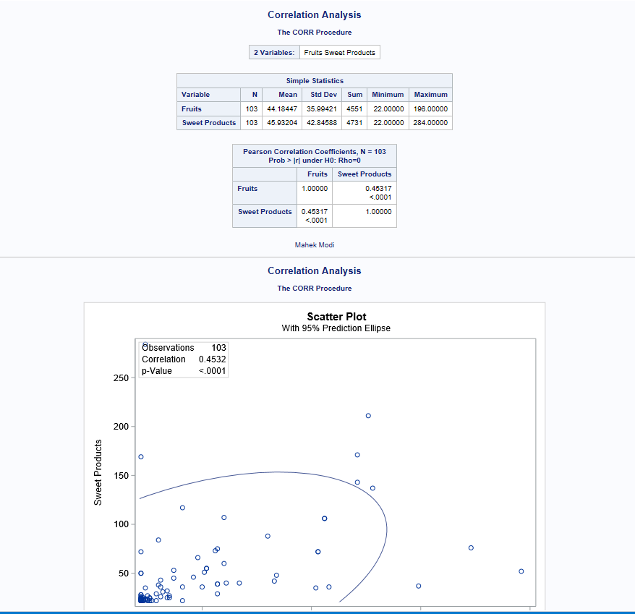

**📉 4. Regression Analysis (Income vs Total Amount Spent)**

* **Tool Used**: Excel + SAS
* **Regression Equation**:

y=0.0311x−1060.3y = 0.0311x - 1060.3y=0.0311x−1060.3

Where:

* + y = Total Amount Spent
  + x = Income
* **P-value**: < 0.0001 → **Statistically significant**
* **R² (Coefficient of Determination)**: **0.6866** → Explains ~69% of spending variation

*Screenshot:*

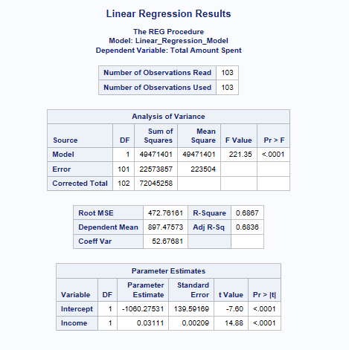

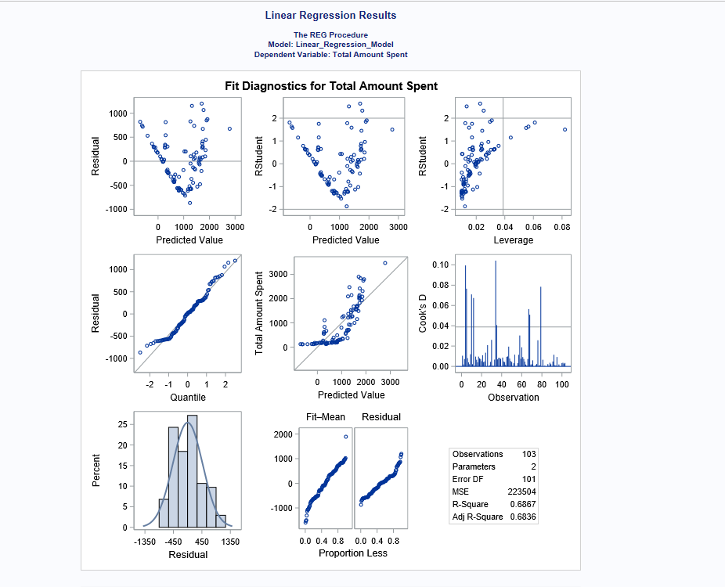

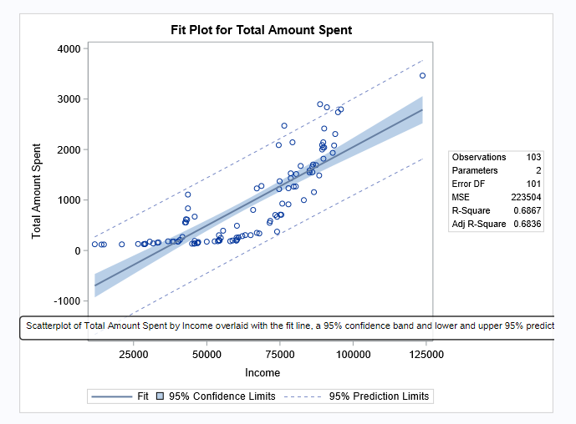

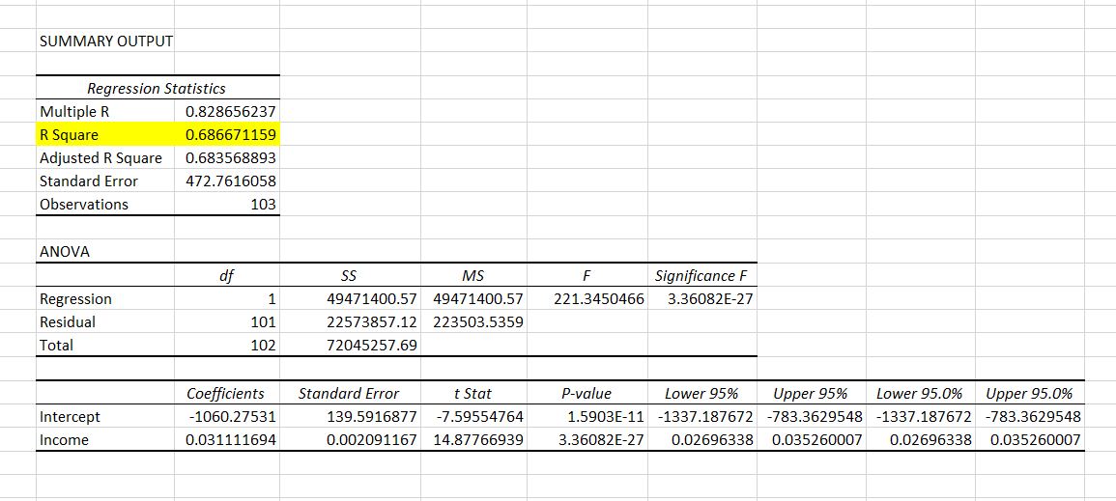

**🔍 Predictive Scenario**

* **Avg. Income**: $62,926.53
* **With $10,000 increase** → Predicted Spend = **$1,207.69**
* **95% Confidence Interval**:
  + Lower Limit: **$734.93**
  + Upper Limit: **$1,680.45**

**💡 5. Hypothesis Test Summary**

| **Hypothesis** | **Statement** | **Result** |
| --- | --- | --- |
| H₀ | No relationship between income & spending | ❌ Rejected |
| H₁ | Significant relationship exists | ✅ Accepted |

* Strong evidence to conclude: **Income significantly influences spending**.